CHAPTER 1
INTRODUCTION
PANDA is an ordering and billing app for customers installed on tables at Cafes. Food Ordering System is an application which will help restaurant to optimized and control over their restaurants. For the waiters, it is making life easier because they don’t have to go kitchen and give the orders to chef easily.

Management point of view, the manager will able to control the restaurant by having all the reports to hand and able to see the records of each employees and orders. This application helps the restaurants to do all functionalities more accurately and faster way. Food Ordering System reduces manual works and improves efficiency of restaurant.

The main goal is to maintain the restaurant’s functions in an effective and accurate manner and it is reducing the use of manual entries. This software helps food orders to maintain day to day records in system. It is keeping a proper record of the database.

This application is helping Food Ordering s to maintain the stock and cash flows and there are many more functionalities, like.
  - To store records.
  - Control orders and services.
  - Billings on the go.
  - Reduce the manual work.
  - Faster ordering system.
  - Control multiple branches.

1.1 Introduction to Database Management System
The main aim of a DBMS is to supply a way to store up and retrieve database information that is both convenient and efficient. By data, we mean known facts that can be recorded and that have embedded meaning. A datum is a unit of data. Meaningful data combined to form information. Hence, information is interpreted data – data provided with semantics. MS. ACCESS is one of the most common examples of database management software.
A database management system (DBMS) refers to the technology for creating and managing databases. Basically, DBMS is a software tool to organize (create, retrieve, update and manage) data in a database.

1.2 More on Data, Information and Knowledge
Knowledge refers to the useful use of information. As you know that information can be transported, stored and shared without much problem and difficulties but the same cannot be said about knowledge. Knowledge necessarily involves a personal experience and practice.

Database systems are meant to handle large collection of information. Management of data involves both defining structures for storage of information and providing mechanisms that can do the manipulation of those stored information. Moreover, the database system must ensure the safety of the information stored, despite system crashes or attempts at unauthorized access.

1.3 Why DBMS?
- To develop software applications in less time.
- Data independence and efficient use of data.
- For uniform data administration.
- For data integrity and security.

1.4 Components of DBMS

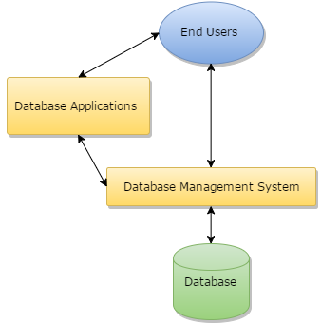
Fig 1.1: Components of DBMS
- Users: Users may be of any kind such as DB administrator, System developer or Database users.
- Database application: Database application may be Departmental, Personal, organization’s and / or Internal.
- Software that allow users to create and manipulate database access,
- Database Collection of logical data as a single unit.

1.5 Advantages of DBMS
A DBMS manage data and has many advantages. These are:
1. Data independence: Application programs should be as free or independent as possible from details of data representation and storage. DBMS can supply an abstract view of the data for insulating application code from such facts.
2. Efficient data access: DBMS utilizes a mixture of sophisticated concepts and techniques for storing and retrieving data competently and this feature becomes important in cases where the data is stored on external storage devices.
3. Data administration: When several users share the data, integrating the administration of data can offer major improvements. Experienced professionals understand the nature of the data being managed and can be responsible for organizing the data representation to reduce redundancy and make the data to retrieve efficiently.
4. Security: Data security means protecting your precious data from unauthorized access. Data in database should be kept secure and safe to unauthorized modifications. Only authorized users should have the grant to access the database. There is a username set for all the users who access the database with password so that no other guy can access this information. DBMS always keep database tamperproof, secure and theft free.
5. Atomicity: DBMS makes sure either the transaction is fully complete, or it is rolled back to the previous committed state. It does not allow the system to be in a partially committed state. In our example above, DBMS commits marks change transaction before calculating the total.
1.6 Disadvantages of DBMS
1. Increased costs: One of the disadvantages of DBMS is Database systems require sophisticated hardware and software and highly skilled personnel. The cost of maintaining the hardware, software, and personnel required to operate and manage a database system can be substantial. Training, licensing, and regulation compliance costs are often overlooked when database systems are implemented.
2. Management complexity: Database systems interface with many different technologies and have a significant impact on a company’s resources and culture. The changes introduced by the adoption of a database system must be properly managed to ensure that they help advance the company’s objectives. Given the fact that database systems hold crucial company data that are accessed from multiple sources, security issues must be assessed constantly.
3. Maintaining currency: To maximize the efficiency of the database system, you must keep your system current. Therefore, you must perform frequent updates and apply the latest patches and security measures to all components.
Because database technology advances rapidly, personnel training costs tend to be significant. Vendor dependence. Given the heavy investment in technology and personnel training, companies might be reluctant to change database vendors.
Consequently, vendors are less likely to offer pricing point advantages to existing customers, and those customers might be limited in their choice of database system components.
4. Frequent upgrade/replacement cycles: DBMS vendors frequently upgrade their products by adding new functionality. Such new features often come bundled in new upgrade versions of the software. Some of these versions require hardware upgrades. Not only do the upgrades themselves cost money, but it also costs money to train database users and administrators to properly use and manage the new features.

Chapter 2
Software & Hardware requirements
2.1 Software requirements
- Operating System: Windows XP/Vista/7.8.1/10
- Microsoft Visual C++ Redistributables: 2008 to 2015 versions.
- IDE: Visual studio code/Sublime text
- Browser: Chrome/Firefox/Internet Explorer
- Full administrator access.
- WAMP Server 3.1.0 with the following services:
- Apache 2.4.27
- MySQL 5.7.19
- PHP 5.6.31
  - Hardware requirements
- RAM: 512MB
- HDD: 500MB
  - Language requirements
- MySQL
- Html
- CSS
- PHP
- JS

Chapter 3
Design
3.1 ER diagram
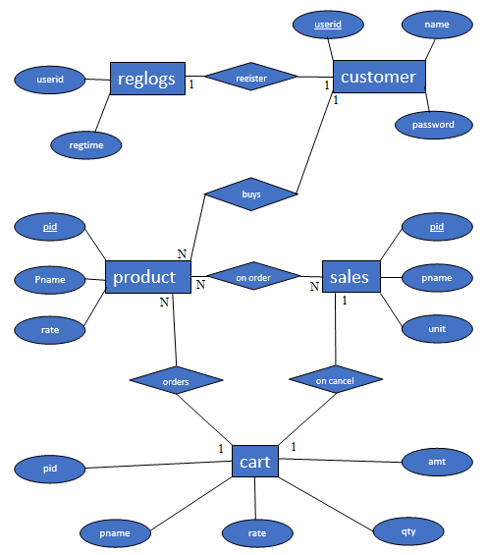

Fig 3.1: ER Diagram
An entity-relationship diagram (ERD) is a data modeling technique that graphically illustrates an information system's entities and the relationships between those entities. An ERD is a conceptual and representational model of data used to represent the entity framework infrastructure.
3.2 Schema diagram

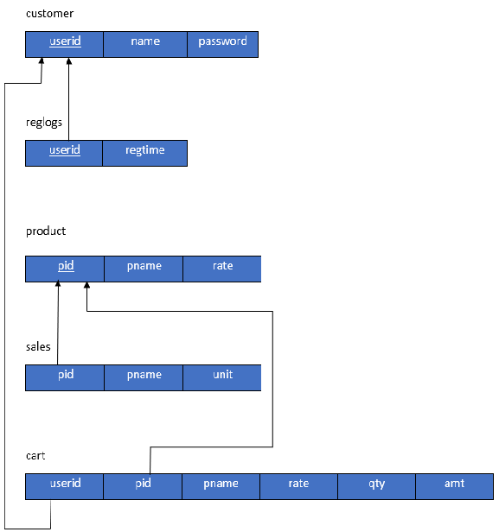
Fig 3.2: Schema Diagram
A database schema is the skeleton structure that represents the logical view of the entire database. It defines how the data is organized and how the relations among them are associated. It formulates all the constraints that are to be applied on the data.

Chapter 4
Implementation
4.1 Table creations
CREATE TABLE REGLOGS(
USERID VARCHAR(20),
REGTIME DATE
FOREIGN KEY(USERID) REFERENCES CUSTOMER(USERID));

CREATE TABLE CUSTOMER(
USERID VARCHAR(20) PRIMARY KEY,
NAME VARCHAR(20),
PASSWORD VARCHAR(20));

CREATE TABLE CART(
PID INTEGER(5) PRIMARY KEY,
PNAME VARCHAR(20),
RATE INTEGER(10),
QTY INTEGER(10),
AMT INTEGER(10)
FOREIGN KEY(PID) REFERENCES PRODUCT(PID));

CREATE TABLE PRODUCT(
PID INTEGER(5) PRIMARY KEY,
PNAME VARCHAR(20),
RATE INTEGER(10));

CREATE TABLE SALES(
PID INTEGER(5) PRIMARY KEY,
PNAME VARCHAR(20),
UNIT INTEGER(10));

4.2 Table insertion
INSERT INTO PRODUCT VALUES (10,’FRIES’,50);
INSERT INTO PRODUCT VALUES (11,’TACO’,50);
INSERT INTO PRODUCT VALUES (20,’WATER’,10);
INSERT INTO PRODUCT VALUES (21,’LIME’,20);
INSERT INTO PRODUCT VALUES (30,’OREO’,50);
INSERT INTO PRODUCT VALUES (31,’PASTRY’,50);
INSERT INTO SALES VALUES (10,’FRIES’,0);
INSERT INTO SALES VALUES (11,’TACO’,0);
INSERT INTO SALES VALUES (20,’WATER’,0);
INSERT INTO SALES VALUES (21,’LIME’,0);
INSERT INTO SALES VALUES (30,’OREO’,0);
INSERT INTO SALES VALUES (31,’PASTRY’,0);

4.3 Queries
SELECT * FROM CUSTOMER WHERE CUSTOMER.USERID='$USERID' AND CUSTOMER.PASSWORD='$PASSWORD'
SELECT * FROM CUSTOMER WHERE CUSTOMER.USERID='$USERID'
INSERT INTO CUSTOMER (CUSTOMER.USERID,CUSTOMER.NAME,CUSTOMER.PASSWORD) VALUES ('$USERID','$NAME','$PASSWORD')

SELECT SUM(CART.AMT) AS TOTAL FROM CART
SELECT CART.PID FROM CART WHERE CART.PID=$PID
UPDATE CART SET CART.QTY=CART.QTY+1, CART.AMT=CART.AMT+$RATE WHERE CART.PID=$PID
INSERT INTO CART (CART.PID,CART.PNAME,CART.RATE,CART.QTY,CART.AMT) VALUES ($PID,'$PNAME',$RATE,1,$RATE)
SELECT * FROM CART
TRUNCATE CART

SELECT * FROM PRODUCT WHERE PRODUCT.PID=$ID
UPDATE SALES SET UNIT=UNIT-1 WHERE SALES.PID=$ID
UPDATE SALES SET UNIT=UNIT-$QTY WHERE SALES.PID=$PID
UPDATE SALES SET UNIT=UNIT+1 WHERE SALES.PID=$ID
UPDATE CART SET QTY=QTY-1,AMT=AMT-RATE WHERE CART.PID=$ID
DELETE FROM CART WHERE CART.QTY=0.

4.4 Triggers
CREATE TRIGGER `REGISTERTIME` BEFORE INSERT ON `CUSTOMER`
FOR EACH ROW INSERT INTO REGLOGS VALUES(NEW.USERID,NOW());

4.5 Stored Procedures
DELIMITER $$
CREATE DEFINER=`ROOT`@`LOCALHOST` PROCEDURE `DROPCART`()
MODIFIES SQL DATA
TRUNCATE CART$$
DELIMITER ;

DELIMITER $$
CREATE DEFINER=`ROOT`@`LOCALHOST` PROCEDURE `ALLCART`()
MODIFIES SQL DATA
SELECT * FROM CART$$
DELIMITER ;

Chapter 5
Snapshots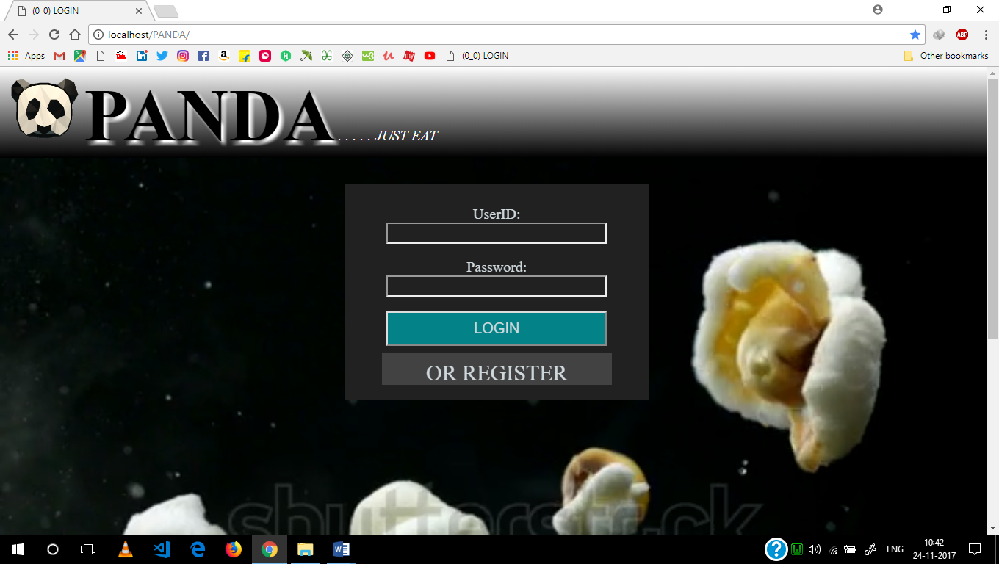 Fig 5.1: Login page
This page tells the existing user to login or to register if they are a new user.

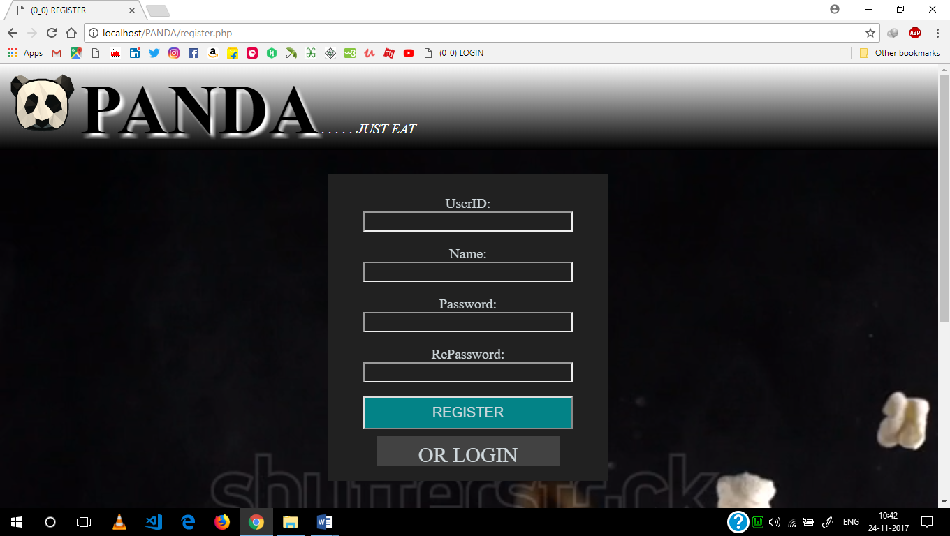
Fig 5.2: Register page
This page asks user to enter details for new Registration or go back to login page.
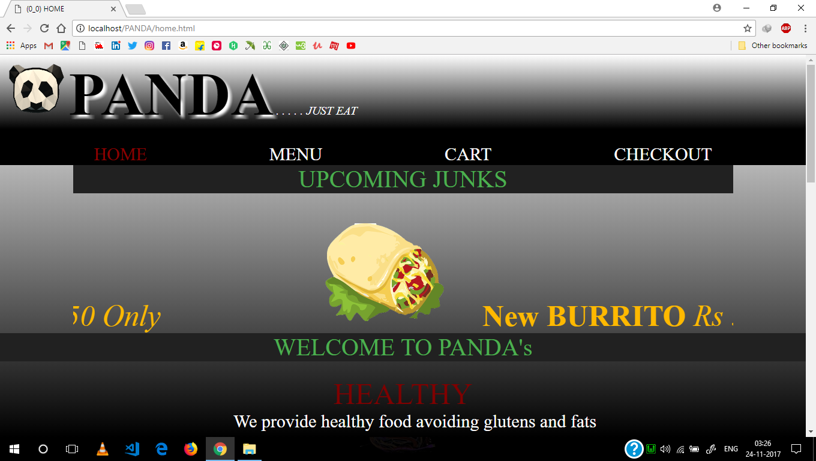Fig 5.3: Home page
This is the first page any user gets to see after login and contains link to another page.

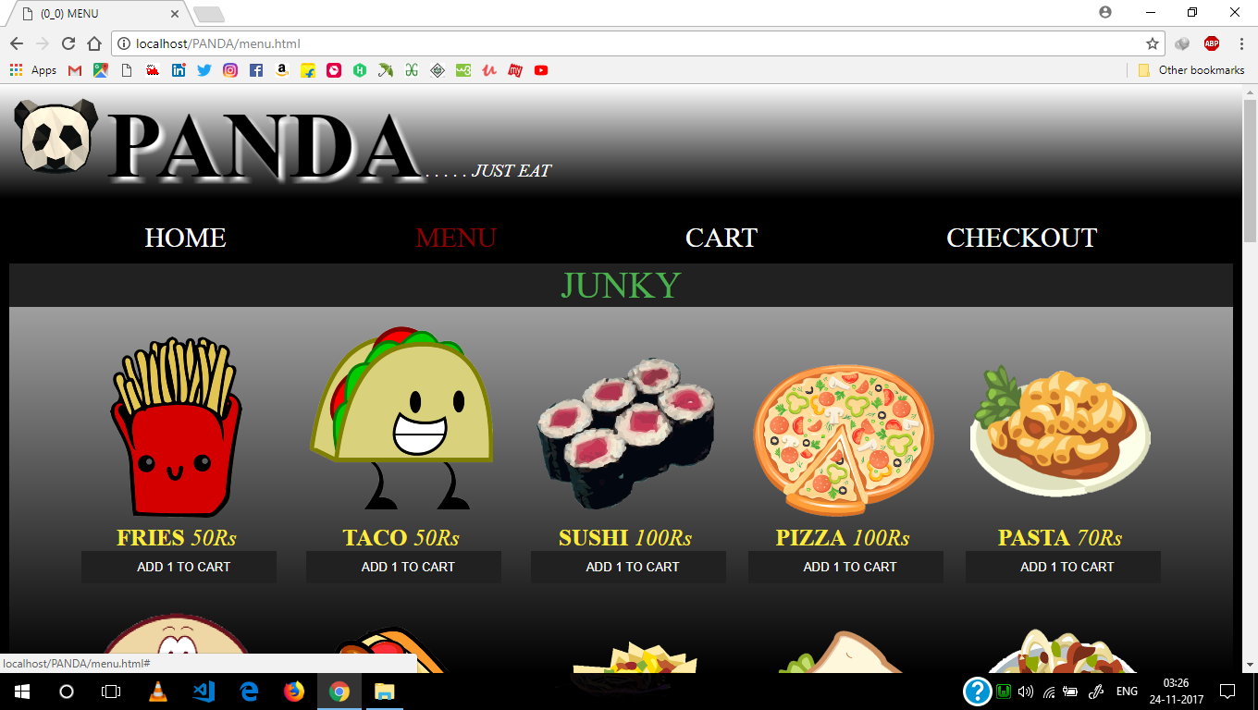Fig 5.5: Menu page
This page shows menu of the cafe where a user can choose among various categories of snacks and add it to cart to proceed further.
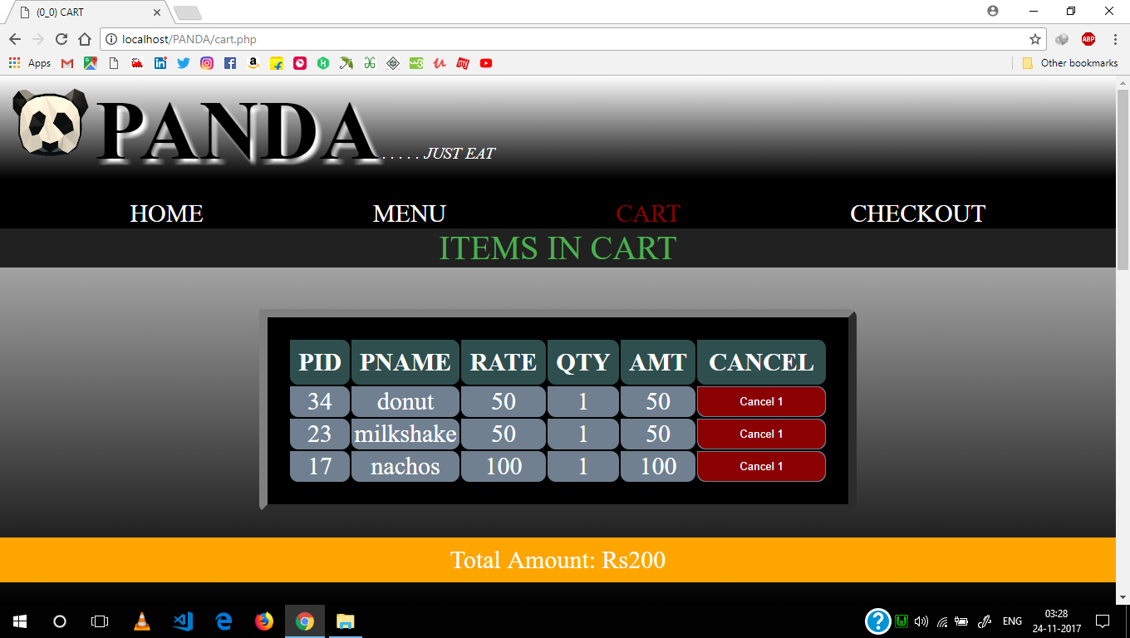Fig 5.6: Cart page
This page is the cart page where a user can cancel the selected food or proceed to make the payment which will navigate user to checkout page.

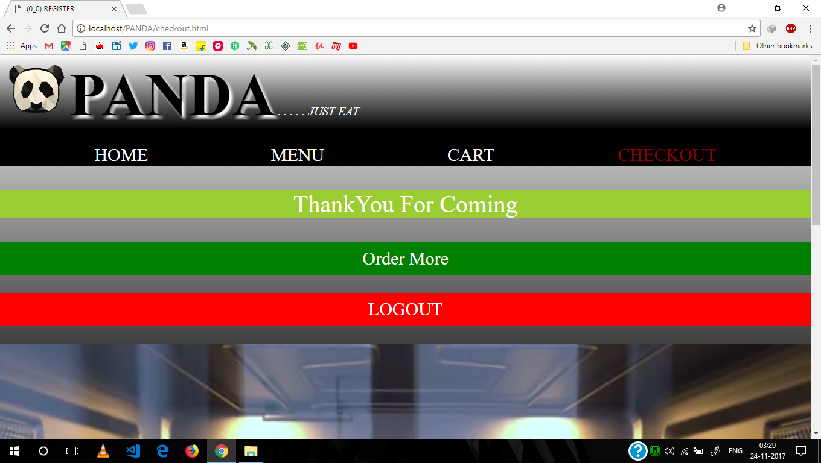 Fig 5.6: Checkout page
This page is the checkout page from here a user can go back to menu page or user can logout from application.
Conclusion & Future enhancement
Conclusion
The main objective of the application is to help Information Science students understands the basics of DBMS, HTML, CSS, PHP, and JAVASCRIPT. The following results have been achieved after completing the system and relate back to the system’s objective.

It should allow Information Science students to browse through the code and application: This can be achieved when students are able to run and install the application. When they run the application, they can browse through the implementation of different objects.

It should allow users to save items to the cart and view the order: The users can add any number of items to the cart from any of the available food categories by simply clicking the Add to Cart button for each item

Future enhancements
The following section describes the work that will be implemented with future releases of the software.
- Customize orders: Allow customers to customize food orders.

- Enhance User Interface by adding more user interactive features

- Provide Deals and promotional Offer details to home page.

- Provide Recipes of the Week/Day to Home Page

- Delivery Options: Add delivery option.

- Order Status: Show only Active orders to Restaurant Employees.

- Integrate with in store touch screen devices like Tablets.
Bibliography
Web References:
- www.php.net
- www.mysql.com
- www.wampserver.com
- www.w3schools.com
- www.udemy.com
Book References:
- DBMS: Ramakrishna - Database Management System 3rd Edition
- PHP: The Complete Reference by Steven Holzner
- PHP & MySQL Web Development by Luke Welling & Laura Thompson

